OFFICIAL COORDINATION REQUEST FOR
NON-ROUTINE OPERATIONS AND MAINTENANCE

COORDINATION TITLE- 24BON048 MOC Avian Array Repairs at PH1, PH2, Spillway
COORDINATION DATE- 22August2024
PROJECT- Bonneville Lock & Dam
RESPONSE DATE- 05September2024

Description of the problem:
Bonneville Dam uses a total of four avian wire arrays for passive avian deterrence throughout the fish passage season. These arrays are located at: Powerhouse 1 (PH1) Tailrace, Spillway Tailrace, Powerhouse 2 (PH2) Tailrace, and at the outfall of the PH2 Corner Collector (B2CC). These avian wire arrays each fan out from an anchor point located on shore. The PH1, PH2 and Spillway avian arrays have been discovered with bent portions of each of their anchoring system (See Figures 1 and 2). Bonneville Project Engineers have determined these 3 anchors pose a significant safety concern with the potential to severely injure personnel or visitors, as well as cause property damage in the vicinity of these high-tension stainless-steel lines if the anchors were to fail. USDA APHIS will remove the current avian wires, modify the anchors to remove any safety hazards, and will restring each avian array.
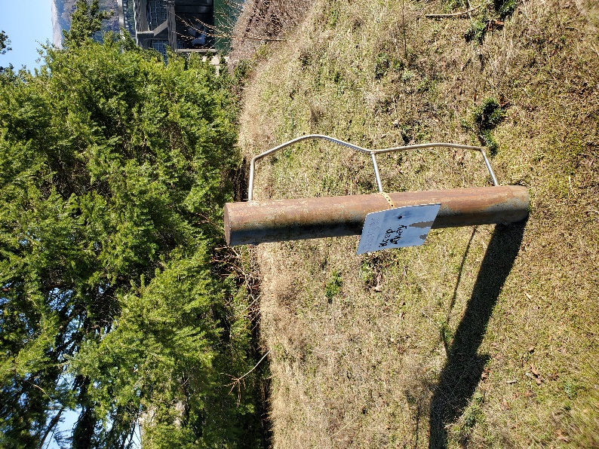
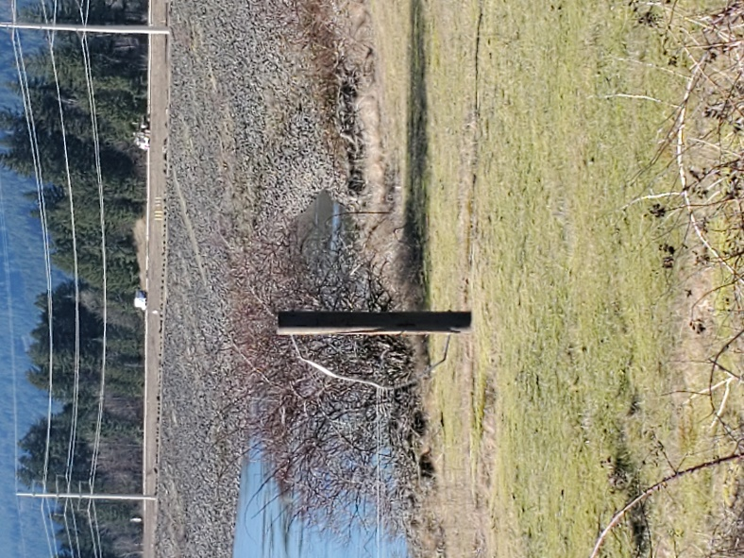
Figure 2. Bent PH2 Avian Deterrence Wire Array Anchor
Figure 1. Bent Spillway Avian Deterrence Wire Array Anchor

Type of outage required:

To safely rehang the PH1 avian wire array, the PH1 Ice and Trash Sluiceway (ITS) will be required to be closed and will be placed under a lockout/tagout clearance for the duration of the boat operations in the PH1 tailrace. This outage is not expected to take longer than 8 hours with the goal of the ITS outage being a half day.
To safely rehang the Spillway avian wire array, Spillway Gates 1-18 will be closed and placed under a lockout/tagout clearance for the duration of boat operations in the Spillway tailrace. Late summer spill for juvenile fish passage ends at 1159 on 31 August, so only spill for attraction flow for Cascades Island Fishway Entrance and Bradford Island B-Branch Fishway Entrance from Bays 1 and 18 will be affected. This outage is not expected to take any longer than 8 hours. The B2CC is not expected to be open at this time however, boats will maintain 150’ or greater distance from the outfall as a safety precaution.
Impact on forebay/tailwater operation none

Impact on facility operation
Fish Units and/or Main Units may have to be throttled down to provide safe boating conditions in the corresponding tailraces and will be assessed on a case-by-case basis by the Project and work crew.

Impact on Unit Priority
No impact on Unit Priority is expected for avian array repairs, however, T11 transformer maintenance outage will be occurring concurrently at the time of avian wire repairs. Unit Priority referenced in MOC 24BON041 for T11 outage will be the following:

During MOC 24BON041 T11 Outage 16 Sept- 03 Oct:
PH2: 15, 16, 17, 18
PH1: 1, 10*, 3, 6, 9, 4*, 5, 8, 7, 2
*As of August 22, 2024, PH1 units 2-10 are forced OOS, however, units 10 & 4 may be returned to service by this T11 outage timeframe.

Impact on spill: Juvenile fish passage spill has concluded for the season. During avian array replacement in the Spillway Tailrace, Spillway Gates 1-18 will be closed and under a lockout/tagout Clearance to allow boats in the Spillway tailrace. This will cause a reduction in adjacent spillbay attraction flow to the fully operational Cascades Island Fishway Entrance and the Bradford Island B-Branch Fishway Entrance when boats are in the Spillway area. The fishway entrances will still maintain FPP required entrance head differential of 1’-2’.

Dates of impacts/repairs: September 17 – September 19
September 17 – ITS outage up to one working day with goal of half day closure

September 18 – Spillway outage

September 19 – Any remaining work on arrays.

Length of time for repairs: During normal daytime working hours.

Analysis of potential impacts to fish:
- Statement about the current year’s run (e.g., higher or lower than 10-year average);
Table 1. Previous year’s (2023) passage numbers at BON vs 10-Year Average (2014-2023) and 2024 Forecasts vs. 10-Year Average (2014-2023).
2023 Fall Chinook | Above 10-Year Average
2023 Steelhead | Below 10-Year Average
2023 Coho | Above 10-Year Average
2023 Lamprey | Above 10-Year Average
2024 Fall Chinook Run | Forecasted to be above 10-Year Average
2024 Coho Run | Forecasted to be above 10-Year Average

- Forecasts reviewed from WDFW’s forecast and model runs webpage at https://wdfw.wa.gov/fishing/management/north-falcon/forecasts
- 10-year averages reviewed from Columbia River DART, Columbia Basin Research, University of Washington. (2024). Adult Passage Daily Counts. Available from https://www.cbr.washington.edu/dart/query/adult_daily

- Estimated exposure to impact by species and age class (i.e., number or percentage of run exposed to an impact by the action);
Table 2. Percentage of adult run exposed to outage period by comparing 10-year average passage during outage timeframe and 10-year average run total. Data obtained from Columbia River DART, Columbia Basin Research, University of Washington. (2024). Adult Passage Daily Counts. Available from https://www.cbr.washington.edu/dart/query/adult_daily
Species | 10-Year Average Passage During Period of Outage | 10-Year Average Total Run | Percentage of Run Affected
Fall Chinook  (adult + jack) | 38,934 | 594,022 | 6.6%
Steelhead | 4,795 | 162,986 | 2.9%
Coho  (adult + jack) | 6,638 | 125,635 | 5.3%
Lamprey* | 28 | 37,430 | 0.07%
*Does not include Lamprey Passage Structure counts

- Type of impact by species and age class (increased delay, exposure to predation, exposure to a route of higher injury/mortality rate, exposure to higher TDG, etc.);

Summary statement - expected impacts on:

Downstream migrants
Impacts to downstream migrants are expected to be minimal during the avian array maintenance. Subyearling Chinook are the predominant downstream migrant during the outage period. However, based on the 10-year average smolt index passage query, 95% passage of this species has occurred by mid-July which is two months prior to the beginning of the avian array outage period (FPC, 2024 https://www.fpc.org/fpc_homepage.php).

Downstream migrants approaching the PH1 forebay on September 17th will not have the Ice and Trash Sluiceway available for a portion of the outage when boats are working in the PH1 tailrace. Any downstream migrants in the area are more likely to be attracted to the PH2 forebay since that is the Priority PH, but any online units running at PH1 will allow for downstream passage. Migrants at PH2 will have the downstream migrant tunnel (DSM2) bypass and turbine passage available throughout the avian array outages.

The B2CC outfall avian array will still be deployed and provide passive deterrence to avian predators in the vicinity of the B2CC outfall. Recent avian counts at BON show that most of the piscivorous birds are observed loafing at the B2CC outfall structure. We will continue to monitor bird numbers at all locations as required by the FPP Appendix L.

Upstream migrants (including Bull Trout)

Pinniped hazing is ongoing and will continue during the avian array repairs.

Fishways are expected to maintain entrance head differential between 1’ – 2’ during this outage. The only exception to this would be if the Fish Units at PH2 need to be throttled down for safe boat operating conditions. If this were to happen, it would be for a few hours during the day while boat operators were in the tailrace of PH2. This avian array outage coincides with T11 outage which causes Main Units 11-14 to be OOS and the secondary attraction flow created by the outflow of priority Unit 11 and adjacent units will not be available (see MOC 24BON041 for more details). Upstream migrants in the PH2 tailrace may be more attracted to the North monolith entrances due to the outflow provided by Priority Unit 18 and adjacent units however, all entrances will be available for upstream passage at the Washington Shore Fishway.

With the ITS closed during work at PH1 tailrace, ITS outfall attraction flow will not be available for the duration of PH1 avian array repairs. We expect this impact to attraction flow be minimal because the fishway entrances at PH1 will be compliant with full entrance head criteria between 1’ – 2’ differential.

Spillgates 1 and 18 will need to be closed and locked out during boat work in the Spillway Tailrace. This will cause a reduction in adjacent attraction flow to the fishway entrances at both the Cascades Island Fishway Entrance and the Bradford B-Branch Fishway Entrance. This may cause upstream migrants to search for entrances for longer, however, we expect the delay to be minimal since both fishways will have full FPP required entrance head.

Lamprey
Impacts are expected to be minimal for lamprey. Less than 0.07% of the total lamprey migration occurs during this time. All fishway entrances will be open and all Lamprey Passage Structures (LPS’s) will be fully operational during this outage.

Comments from agencies

Final coordination results

After Action update (After action statement stating what the effect of the action was on listed species. This statement could simply state that the MOC analysis was correct and the action went as expected, or it could explain how the actual action changed the expected effect (e.g., you didn’t need to close that AWS valve after all, so there was no impact of the action). List any actual mortality noted as a result of the action)

Please email or call with questions or concerns.
Thank you,

Patricia Madson
USACE Portland District
Fisheries Field Unit
patricia.l.madson@usace.army.mil
541-374-8801

Scott Fielding
NWP Operations Division Fishery Section
Scott.D.Fielding@usace.army.mil
503-808-4318

